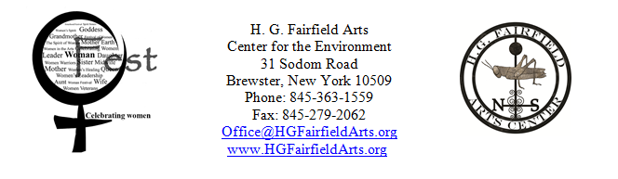
Woman Fest Tent Sponsorship Opportunities

Thank you for supporting this two-day festival to celebrate women.
Net proceeds from Woman Fest benefit H. G. Fairfield Arts’ programming for women.

Co- Sponsor Fee: $50

In return for co-sponsoring a tent, you will receive the following benefits:
- Your organization’s name in our program
- Free information booth space at the sponsored tent
- Invitation to the Social Hour (Wednesday, August 7th at 6pm) in the Hospitality Tent

Name of organization (as you wish it to appear on promotional materials): ____________________________________________________________________________________
Contact person: ______________________________ Phone number: ___________________________
E-Mail: ______________________________________ Website: ________________________________

Which tent are you interested in sponsoring? Call us to get the contact information for your Tent Champion.

□ Childcare Tent
□ Women and Health Tent
□ Women and Military Service Tent
□ Fine Arts Tent
□ Performing Arts Tent
□ (Economic) Power of Women Tent
□ Drumming Tent
□ Cultural Tent
□ LGBTQ Tent
□ Women Bikers Tent
□ Women and Spirituality Tent
□ Women of Color Tent
□ Women in Sports Tent
□ Tent of the Environment
□ Women in Media and Film

Co-sponsoring a tent is more than just a monetary donation; your input helps shape the tent’s focus.
Please reach out to your contacts to help promote Woman Fest. Your Tent Champion will contact you.

Payment for your sponsorship should be made out to:
H. G. Fairfield Arts with “Woman Fest Tent Sponsor” in the memo.
Please postmark your letter before July 26th, 2013
Questions?: E-mail Office@HGFairfieldArts.org or call (845) 363-1559.

H. G. Fairfield Arts Center for the Environment Inc. is registered with the IRS as a
501 (c) (3) not-for-profit corporation, and with the NY State Charities Bureau.

RECEIPT:

Name of your business:…………………………………………………

Contact person……………………………………………….

Address:………………………………………………….

City:………………………………………………………

State/ Zip:………………………………………………...

Telephone:……………………………………………….

Email:…………………………………………………….

Your website address ……………………………………………..

Tent sponsored:………………………………………………….

Amount enclosed: ………………………………………………………..

Questions?: call 845-363-1559

Mail donations to:

H. G. Fairfield Arts
Center for the Environment Inc.
31 Sodom Road
Brewster, New York 10509

Thank you for supporting this inclusive forum to celebrate the strengths and accomplishments of women from all walks of life.

