Woman Fest
August 8 & 9, 2013 8am Thursday – 9pm Friday
Vendor Form

Please fill out and e-mail this form to Office@HGFairfieldArts.org.
Vendor fee is $75. Info booth fee is $25.

Contact Name: __________________________________________________
Business Name: _____________________________________________________
Business website: _________________________________________________
E-Mail: _________________________________________________
Phone Number: __________________________________________
Will you have an: € info booth € vendor booth
Are you a food vendor? € Yes € No
If yes, what Health Department permits do you have?
_____________________________________________________
Please describe your booth: _________________________________________________
_________________________________________________________________________
What day(s) will you be attending? € August 8 € August 9

Please consider donating a small prize to our raffle.
Raffle Prize Description: _____________________________________________________

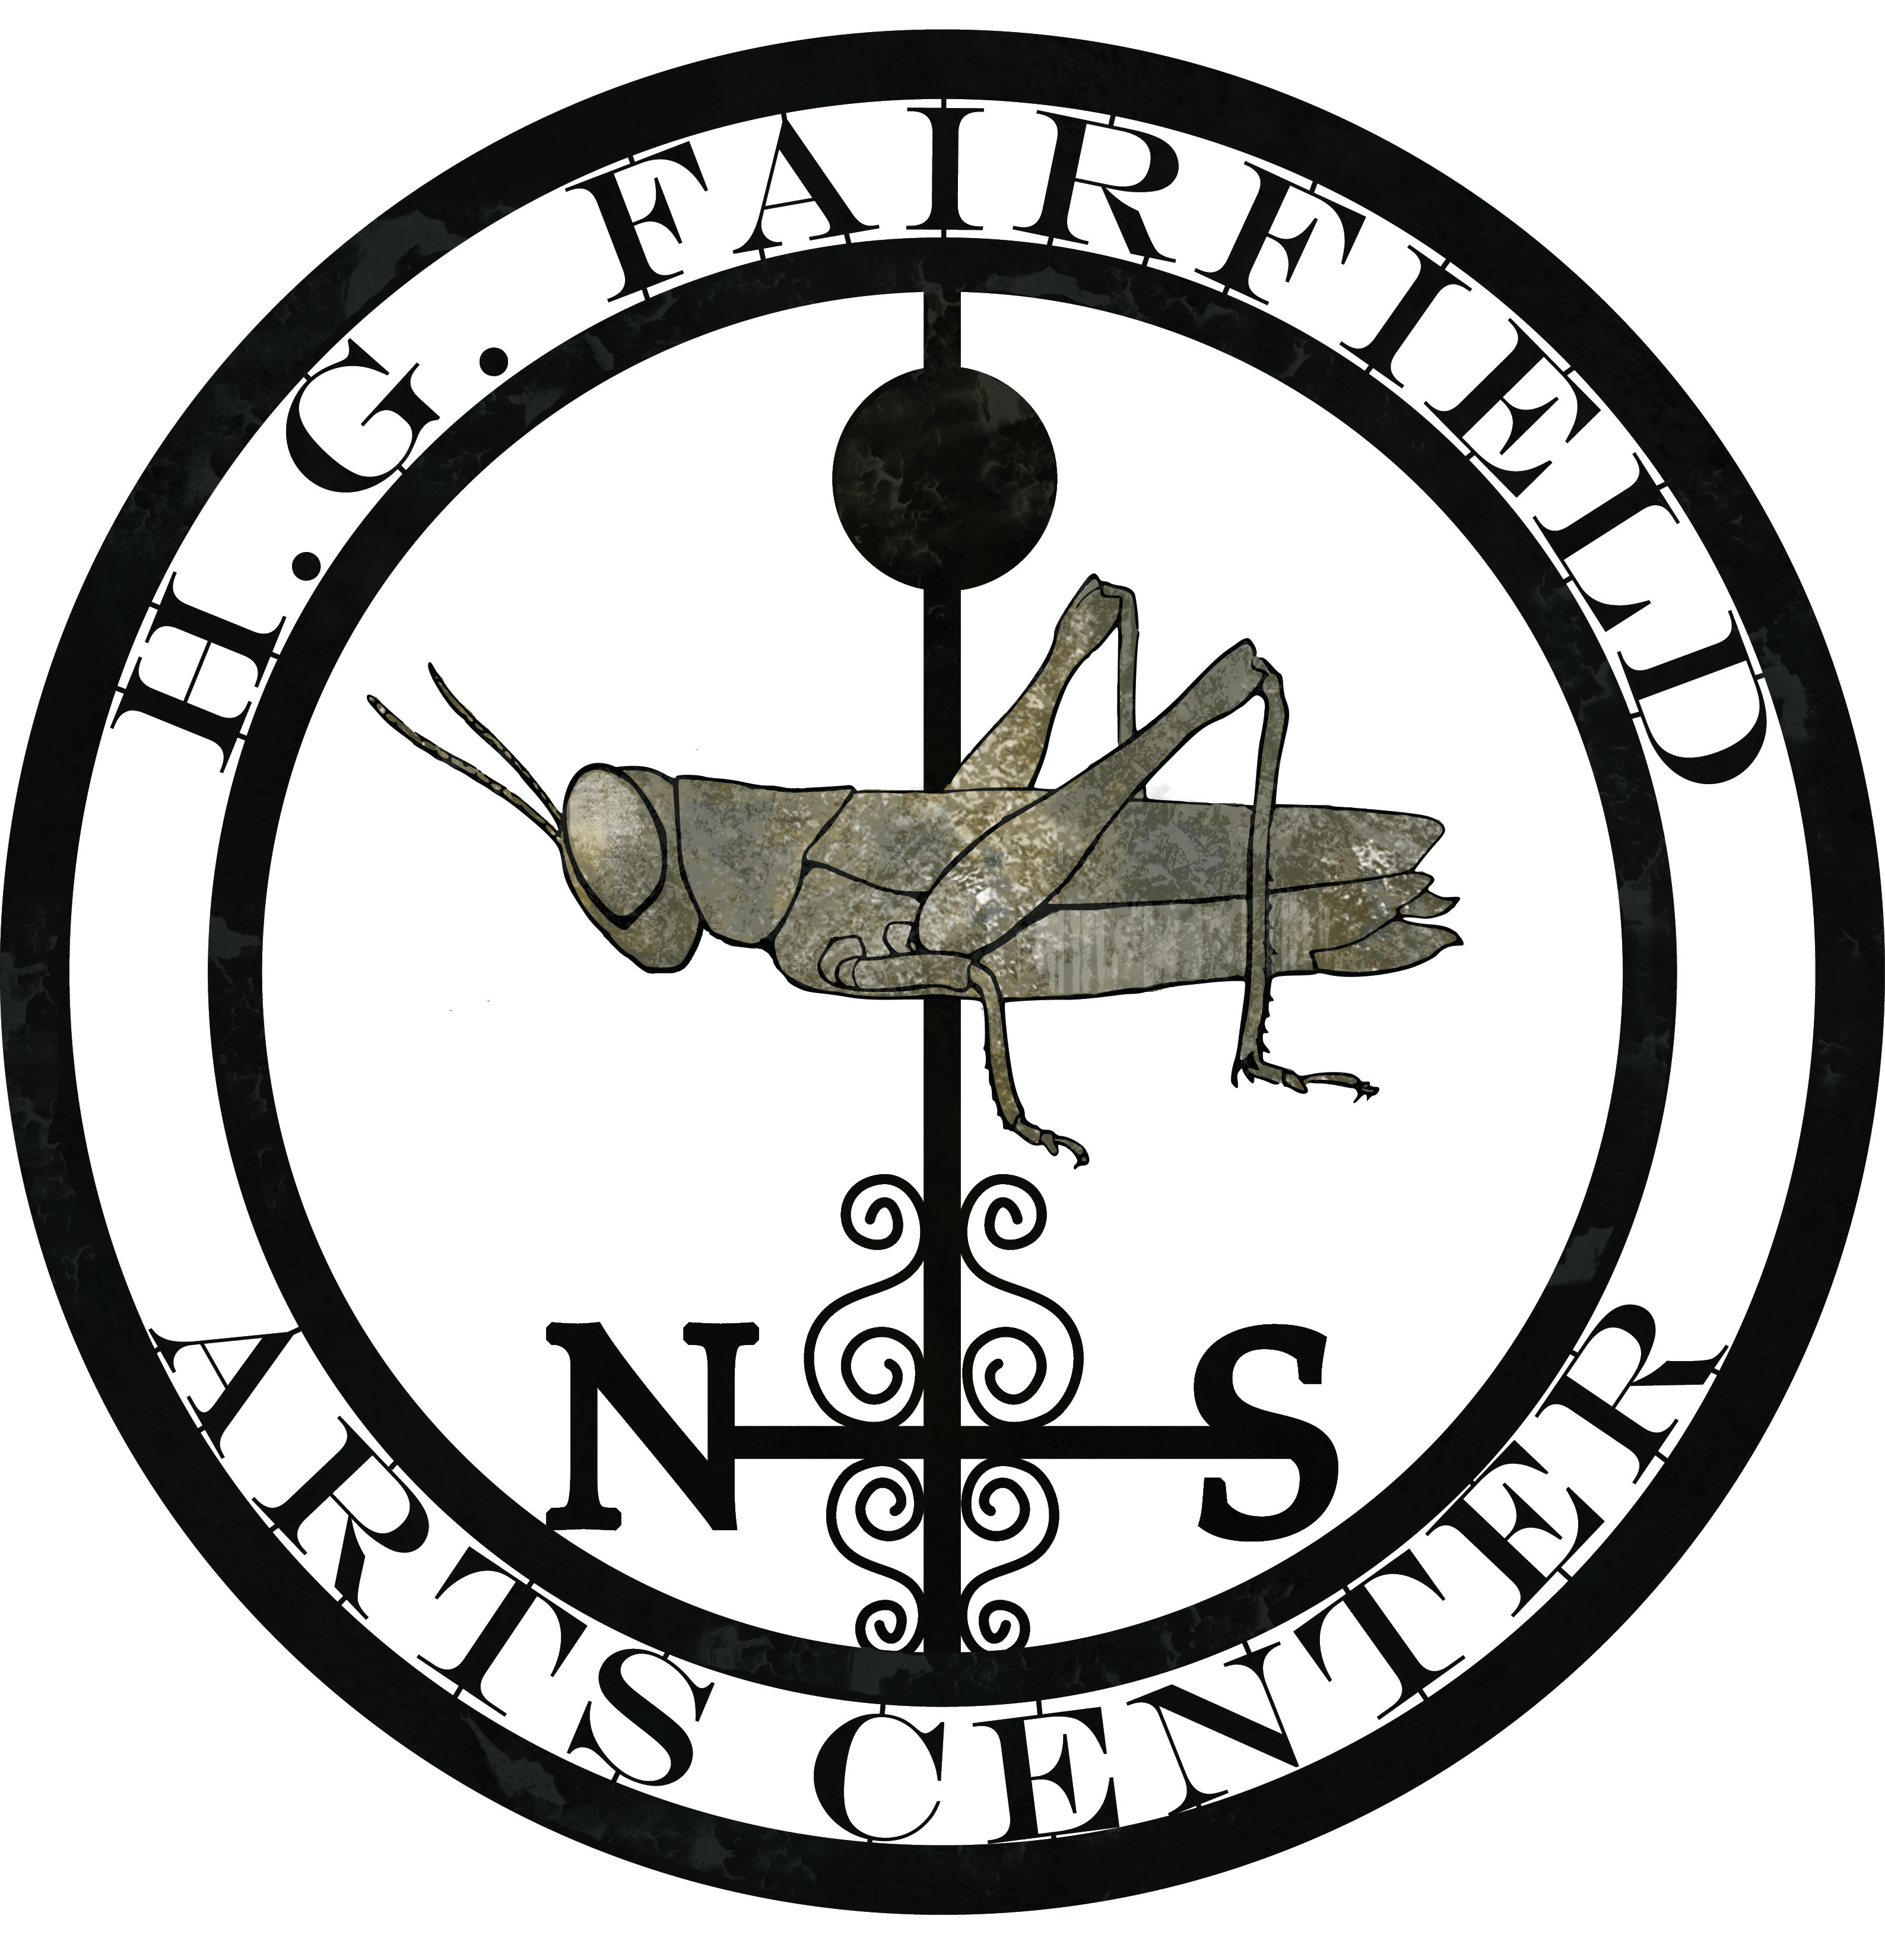
Checks can be made payable to: H. G. Fairfield Arts
31 Sodom Road
Brewster, NY 10509

Call (845) 363-1559 for more information or if you have any questions.

