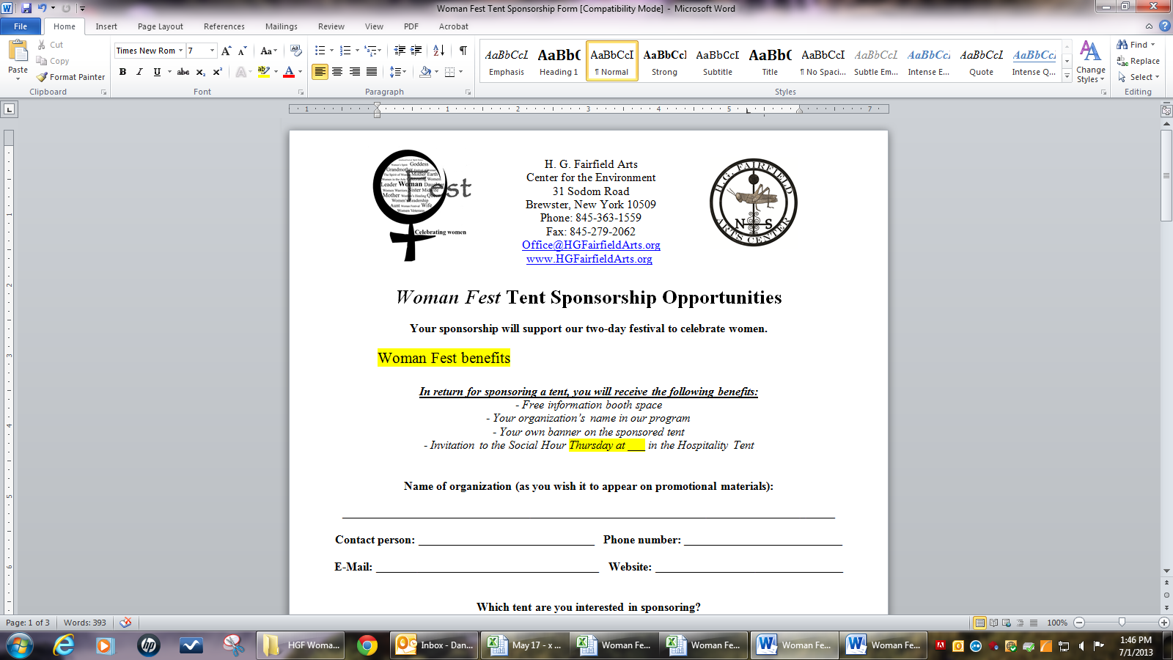
Woman Fest
Tent Champion Form

August 8 & 9, 2013
Rain date: August 10th
Setup: August 7th Strike: August 10th
8am Thursday – 9pm Friday

Champion Name: _________________________________________________________________
E-Mail: _______________________________________________________________________
Phone Number: ________________________________________________________________
What tent will you be championing? _______________________________________________
Do you need: □ a tent/shade structure □ electricity □ sound
Do you have a tent coordinator for each day? (it can be you) □ Yes □ No
What activities or workshops do you plan to have?
__________________________________________________________________________________________________________________________________________________________________________________________________________________________________________
What materials do you need for these activities and how do you plan to obtain them?
____________________________________________________________________________________________________________________________________________________________
What other groups will be involved? (Please include contact name, organization name, and phone number for each group)
________________________________________________________________________________________________________________________________________________________________________________________________________________________________________________________________________________________________________________________
Who will be volunteering at your tent? (Please include each contact’s name and phone number)
__________________________________________________________________________________________________________________________________________________________________________________________________________________________________________
Which sponsors have you obtained for the event, and what will they be donating? (Please include each sponsor’s name and phone number)
______________________________________________________________________________________________________________________________________________________________________________________________

Please submit a schedule of events for each day. (e-mail: Office@HGFairfieldArts.org)

Ask about our Venue Checklist if you need a resource for planning.
If you have any questions, please call (845) 363-1559.

