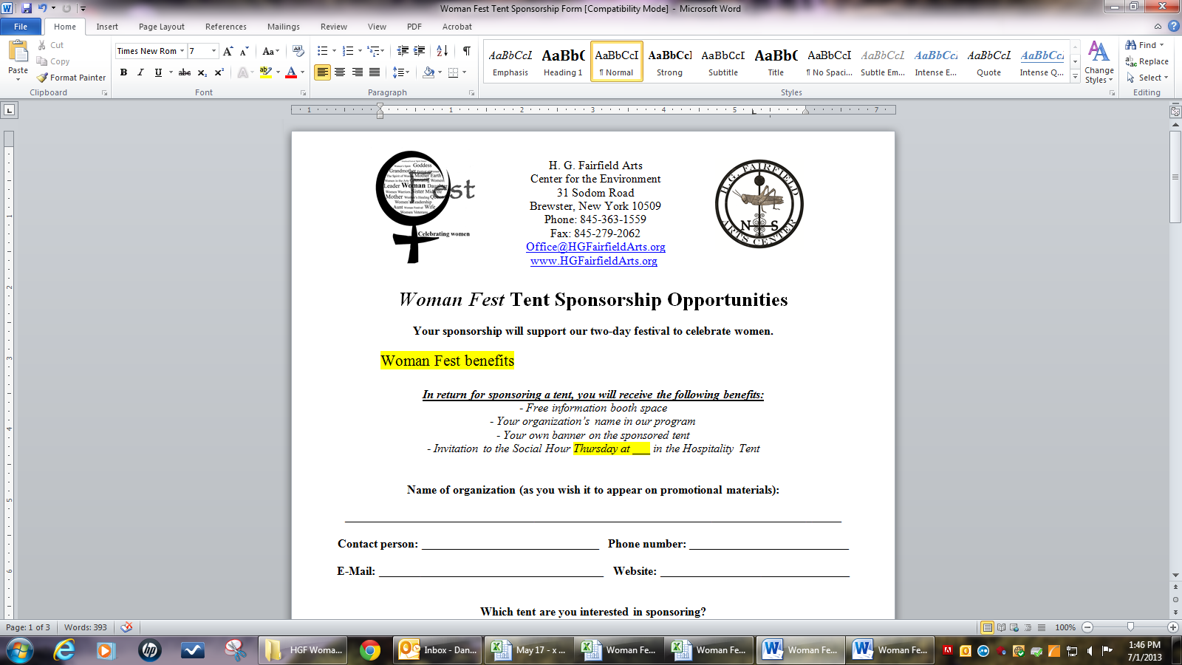
Woman Fest
Performance Form
www.HGFairfieldArts.org
August 8 & 9, 2013
Rain date: August 10th
8am Thursday – 10pm Friday

Name:________________________________________________________________________
E-Mail: __________________________________ Phone Number: _______________________
Are you a woman, or is your performance woman-friendly? □ Yes
Which are you registering for? □ Daytime Talent □ Open Mic Stage
Daytime Talent is for experienced performers looking to promote themselves at our regional festival. For the Open Mic Stage, each performer is allowed one song or one 5-minute act, and will be part of a contest with prizes.
Daytime Talent: Noon – 6pm, Thursday and Friday
Availability: □ Thursday □ Friday At what times? _______________________________________
How long does your set take? (max: 45 minutes)
__________________________________________________________________________________________
Please describe your performance. (such as what music genre)
____________________________________________________________________________________________________________________________________________________________________________________________________
Please email us your tech rider at Office@HGFairfieldArts.org with “Tech Rider” as the subject line. Please include links to your music samples. We will contact you with your time slot.

Open Mic Stage Pre-registration: 7pm-8:30pm, Thursday
Describe your song/performance. (max: 5 minutes)
__________________________________________________________________________________________We will contact you with your time slot. Please note that walk-on spots, welcome from 8:30 – 9:00pm, will be limited to first come, first served.

Video Consent Form
I hereby consent to appear in a video presentation of the Woman Fest Open Mic Stage performances, produced by H. G. Fairfield Arts Center for the Environment.
I understand that this video may be reproduced and marketed and that I will receive no monetary compensation for my appearance in this video.
I further understand that my actual name may be used in the narration of the video.
I further understand that I will not have any editorial control over the final product and my portion of the video.

____________________________________ ____________________________________ ___________
Signature Name (Please Print) Date

____________________________________
Signature of Parent/Guardian
if under 18 years of age

Please sign and mail this form to:

H. G. Fairfield Arts Center for the Environment
31 Sodom Road
Brewster, NY 10509

OR

Be prepared to fill out this form the day of your performance.

