Nimham Mountain Music Festival
May 11, 2013 2-10pm
Vendor Form

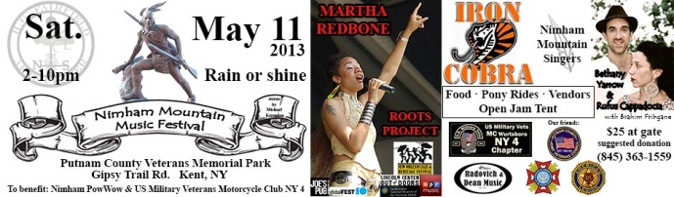
Please fill out and e-mail this form to Office@HGFairfieldArts.org.
Vendor fee is $75.

Contact Name: __________________________________________________
Business Name:_______________________________________________________
Business website: _________________________________________________
E-Mail: _________________________________________________
Phone Number: __________________________________________
Are you a food vendor? □ Yes □ No
If yes, what Health Department permits do you have?
_____________________________________________________
If no, what do you sell? _____________________________________________________

Checks can be made payable to: H. G. Fairfield Arts
31 Sodom Road
Brewster, NY 10509

Call (845) 363-1559 for more information or if you have any questions.

