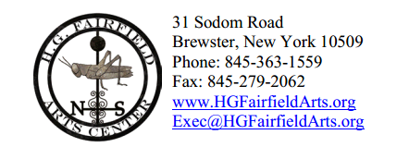
Woman Fest
Workshop Proposal Form

Please write a brief (max. 500 words) proposal describing your workshop. Be sure to include the name of the tent in which you would hold the workshop, the length of the workshop, the content of the workshop, and if you will need any specific materials (i.e. electricity, extra chairs).

If you have any questions, contact our office or your Tent Champion. Submit this proposal form via email or snail mail no later than July 25th, 2013.

