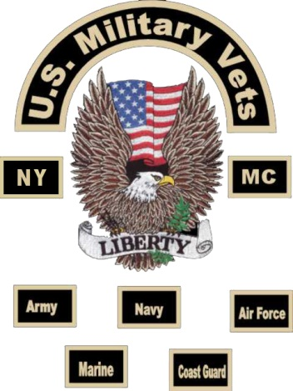
1st Annual PTSD / TBI Awareness Day
Sponsored by USMVMC NY4
Community Day
Motorcycle & Car Show
Pre-register: first come first serve
When: Sat. April 26th 2014 Where: Verkeerder Kill Park
3232 Route 52, Pine Bush, NY 12566

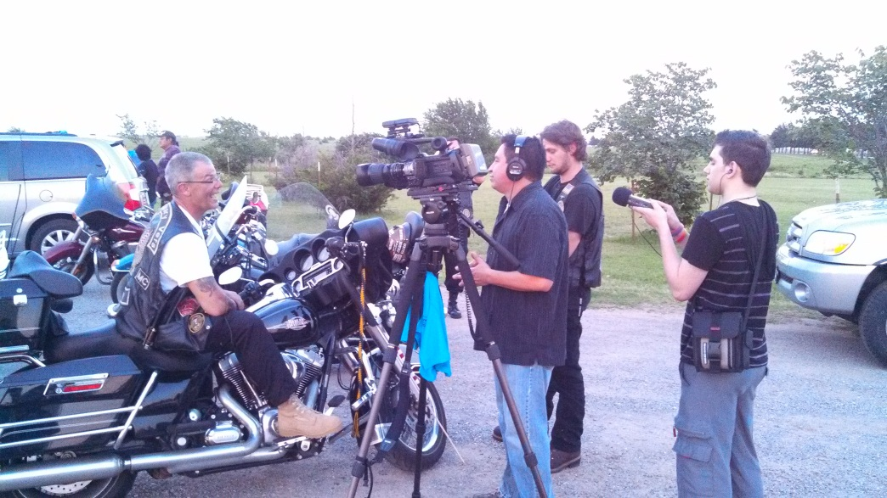
Rain or Shine 10am to 4pm

● 50/50 ● Raffles ● Bouncy Castles
● Cotton Candy ● Snow Cones ● Dunking Booth

DONATION: $10.00 per person ~INCLUDES ALL ENTERTAINMENT~
SCOUTS IN CLASS “B” Uniform $5.00 - Under 5 Free

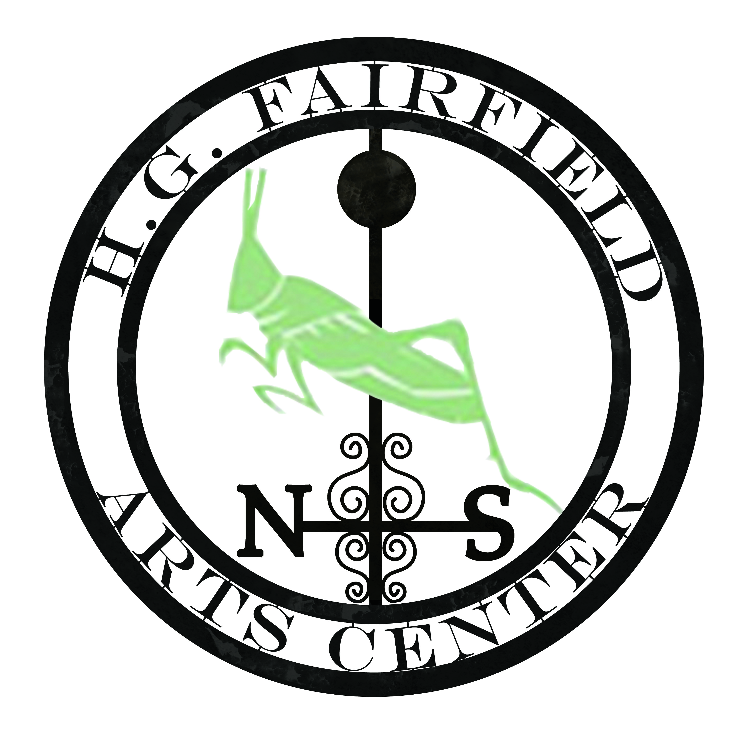
Refreshments…Vendors…Fun Workshops! Sponsorships Welcome: Get your name out there!
Email: Lisa_skinner67@yahoo.com
Phone: Lisa: 845-978-4666 Ray: 845-978-4664
Co-Sponsor: www.HGFairfieldArts.org

