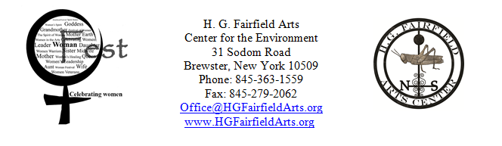
Woman Fest Tent Sponsorship Opportunities

Thank you for supporting this two-day festival to celebrate women.
Net proceeds from Woman Fest benefit H. G. Fairfield Arts’ programming for women.

Co-Sponsor Fee: $50

In return for co-sponsoring a tent, you will receive the following benefits:
1 ticket to Woman Fest
Free information booth space
Your business cards at our Hospitality Tent
A post on our facebook & twitter with your business logo and a link to your site
A link to your website through our site
Thank you letter and recognition of your tax deductible donation to H. G. Fairfield Arts
Certificate of Sponsorship to post in your place of business
Your own banner at the sponsored tent, with a sash from H. G. Fairfield denoting you as a Tent Sponsor

Name of organization (as you wish it to appear on promotional materials): ____________________________________________________________________________________
Contact person: ______________________________ Phone number: ___________________________
E-Mail: ______________________________________ Website: ________________________________

Which tent are you interested in sponsoring? Call us to get the contact information for your Tent Champion.

□ Childcare Tent
□ Women and Health Tent
□ Women and Military Service Tent
□ Women and Arts Tent
□ Women and Power Tent
□ LGBTQ Tent
□ Women and Spirituality Tent
□ Women in Sports Tent
□ Tent of the Environment
□ Women and Media

Co-sponsoring a tent is more than just a monetary donation; your input helps shape the tent’s focus.
Please reach out to your contacts to help promote Woman Fest. Your Tent Champion will contact you.

Payment for your sponsorship should be made out to:
H. G. Fairfield Arts with “Woman Fest Tent Sponsor” in the memo.
Please postmark your letter before July 26th, 2013
Questions?: E-mail Office@HGFairfieldArts.org or call (845) 363-1559.

H. G. Fairfield Arts Center for the Environment Inc. is registered with the IRS as a
501 (c) (3) not-for-profit corporation, and with the NY State Charities Bureau.

RECEIPT:

Name of your business:…………………………………………………

Contact person……………………………………………….

Address:………………………………………………….

City:………………………………………………………

State/ Zip:………………………………………………...

Telephone:……………………………………………….

Email:…………………………………………………….

Your website address ……………………………………………..

Tent sponsored:………………………………………………….

Amount enclosed: ………………………………………………………..

Questions?: call 845-363-1559

Mail donations to:

H. G. Fairfield Arts
Center for the Environment Inc.
31 Sodom Road
Brewster, New York 10509

Thank you for supporting this inclusive forum to celebrate the strengths and accomplishments of women from all walks of life.

