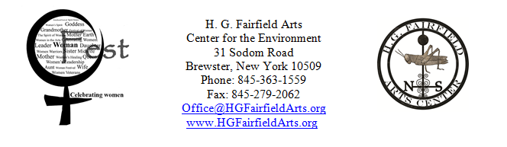

Woman Fest General Sponsorship Opportunities
Net proceeds from Woman Fest benefit H. G. Fairfield Arts’ programming for women.

_______________________________________________________________________________________________________

Sacajawea – $5,000+
- 6 tickets to Woman Fest
- 20 tickets in the raffle
- Your business mentioned in Opening and Closing ceremonies
- A video interview, to be aired on Comcast 8
- Free information booth space
- Your business cards at our Hospitality Tent
- Your business logo (large) on our program
- Your logo (large) will appear on our website’s homepage webslider
- A post on our facebook & twitter with your business logo and a link to your site
- Your business logo (large) on our facebook cover photo
- A link to your website through our site
- Thank you letter and recognition of your tax deductible donation to H. G. Fairfield Arts
- Certificate of Sponsorship to post in your place of business

Sybil Ludington – $2,500- 4,999
- 4 tickets to Woman Fest
- 15 tickets in the raffle
- A video interview, to be aired on Comcast 8
- Free information booth space
- Your business cards at our Hospitality Tent
- Your business logo (medium) on our program
- A post on our facebook & twitter with your business logo and a link to your site
- Your business logo (medium) on our facebook cover photo
- A link to your website through our site
- Thank you letter and recognition of your tax deductible donation to H. G. Fairfield Arts
- Certificate of Sponsorship to post in your place of business

Ruby Bridges – $1,000-2,499
- 2 tickets to Woman Fest
- 10 tickets in the raffle
- A video interview, to be aired on Comcast 8
- Free information booth space
- Your business cards at our Hospitality Tent
- Your business name on our program
- A post on our facebook & twitter with your business logo and a link to your site
- Your business name on our facebook cover photo
- A link to your website through our site
- Thank you letter and recognition of your tax deductible donation to H. G. Fairfield Arts
- Certificate of Sponsorship to post in your place of business

Indira Gandhi – $50-999
- 1 ticket to Woman Fest
- Free information booth space
- Your business cards at our Hospitality Tent
- Your business name on our program
- A post on our facebook & twitter with your business logo and a link to your site
- A link to your website through our site
- Thank you letter and recognition of your tax deductible donation to H. G. Fairfield Arts
- Certificate of Sponsorship to post in your place of business

Please feel free to contact us if you would like to work out an individualized sponsorship plan… also, ask about our Tent Sponsorship Opportunities!

http://www.hgfairfieldarts.org/wf-sponsorship

Payment for your sponsorship should be made out to:
H. G. Fairfield Arts with “Woman Fest Sponsor” in the memo.
Please postmark your letter before July 26th, 2013
Questions?: E-mail Office@HGFairfieldArts.org or call (845) 363-1559.

H. G. Fairfield Arts Center for the Environment Inc. is registered with the IRS as a
501 (c) (3) not-for-profit corporation, and with the NY State Charities Bureau.

RECEIPT:

Name of your business:…………………………………………………

Contact person……………………………………………….

Address:………………………………………………….

City:………………………………………………………

State/ Zip:………………………………………………...

Telephone:……………………………………………….

Email:…………………………………………………….

Your website address ……………………………………………..

Sponsorship level:………………………………………………….

Amount enclosed: ………………………………………………………..

Please e-mail your logo to Danielle.Nickerson@HGFairfieldArts.org
Questions?: call 845-363-1559

Mail donations to:

H. G. Fairfield Arts
Center for the Environment Inc.
31 Sodom Road
Brewster, New York 10509

Thank you for supporting this inclusive forum to celebrate the strengths and accomplishments of women from all walks of life.

